Offline 1
Name:Rafi Abrar Kabir
Student ID:011212012
Section:D
CourseTitle: Data Structure and Algorithms 2 Laboratory
Course Code: CSE 2218

Fibonacci in Normal Approach:
#include <stdio.h>
#include<time.h>
int main()
{
int n;
scanf("%d", &n);
clock_t startingTime, endingTime;
float timeReq;
startingTime = clock();
int num = Fib_normal(n);
endingTime = clock();
timeReq = ((double)(endingTime - startingTime))/CLOCKS_PER_SEC;
printf("Fibonacci number is %d & Time taken: %f", num, timeReq);
return 0;
}
int Fib_normal(int n)
{
if(n <= 0)
return 0;
else if(n == 1)
return 1;
else
return Fib_normal(n-1) + Fib_normal(n-2);
}

Fibonacci in Dynamic Approach:

#include <stdio.h>
#include<time.h>
int ArrayOfFibonacci[200];
int Fib_dynamic(int n);
int main()
{
int n;
scanf("%d", &n);
for(int i=0;i<=n;i++){
ArrayOfFibonacci[i]=0;
}
clock_t startingTime, endingTime;
float timeReq;
startingTime = clock();
int num = Fib_dynamic(n);
endingTime = clock();
timeReq = ((double)(endingTime - startingTime))/CLOCKS_PER_SEC;
printf("Fibonacci number is %d & Time taken: %f", num, timeReq);
return 0;
}
int Fib_dynamic(int n)
{
if (n <= 1)
{
return n;
}
if (ArrayOfFibonacci[n] != 0)
{
return ArrayOfFibonacci[n];
}
ArrayOfFibonacci[n] = Fib_dynamic(n-1) + Fib_dynamic(n-2);
return ArrayOfFibonacci[n];
}
Table:
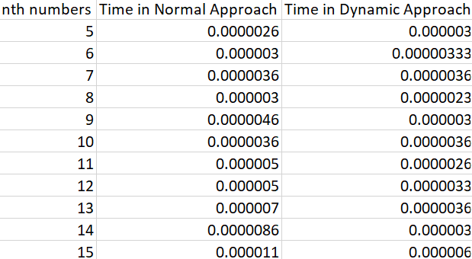

Graph:
Light Blue->Fibonacci in Normal Approach
Dark Blue->Fibonacci in Dynamic Approach
In X-Axis: nth numbers
In Y-Axis: Time taken
